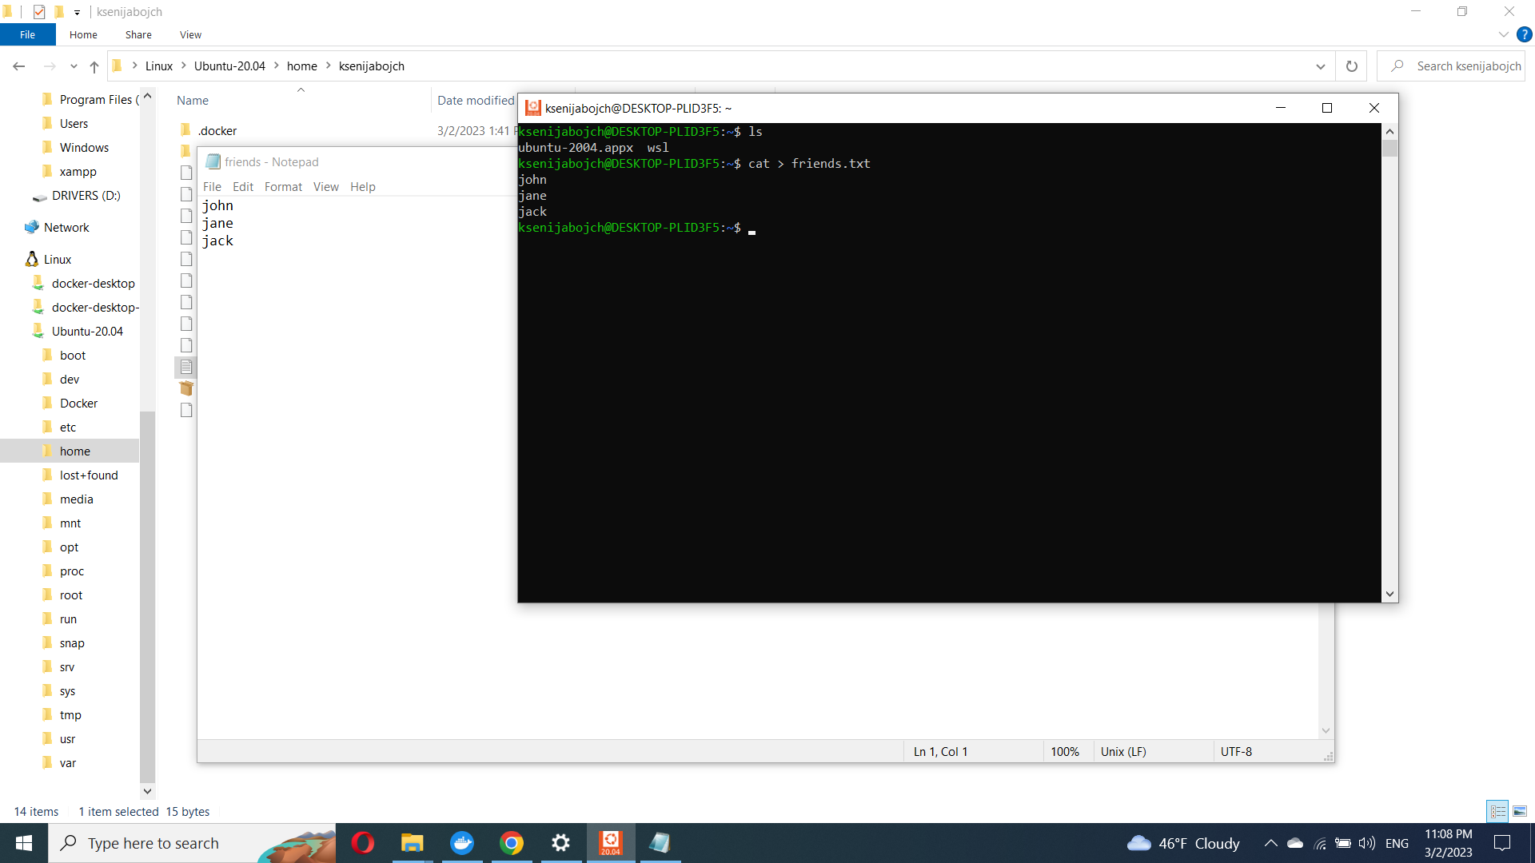

Create a file friends.txt with a list of names of three of your friends on separate lines.

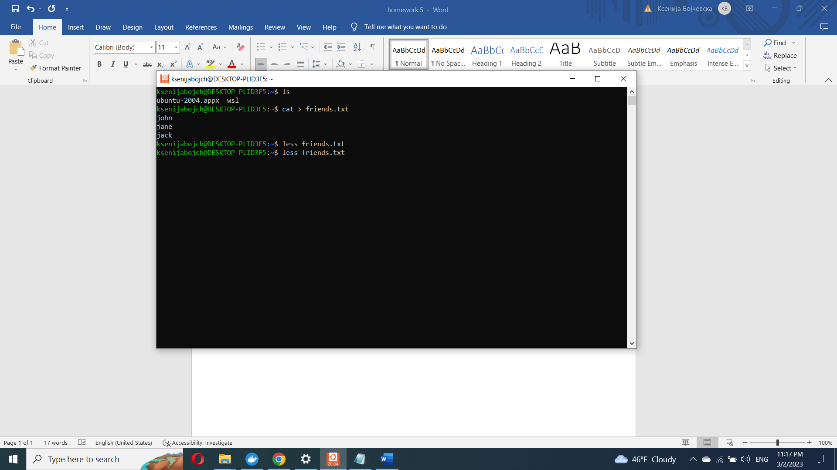

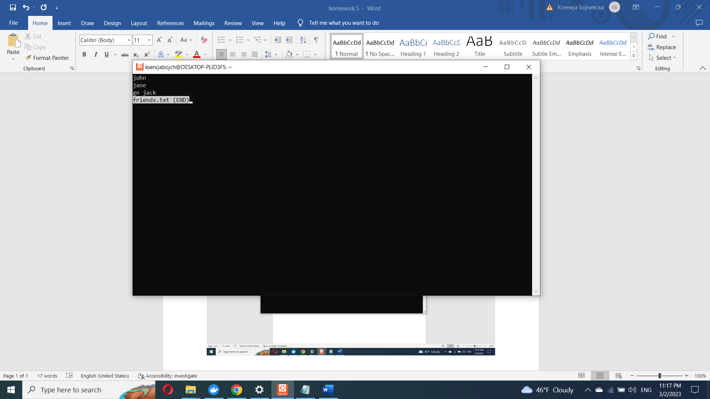

Display the contents of friends.txt on the console.

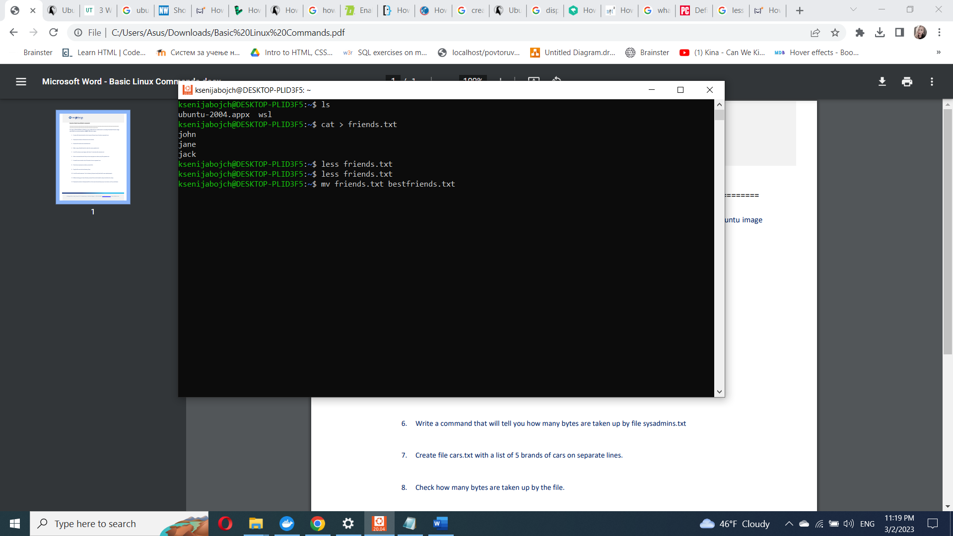

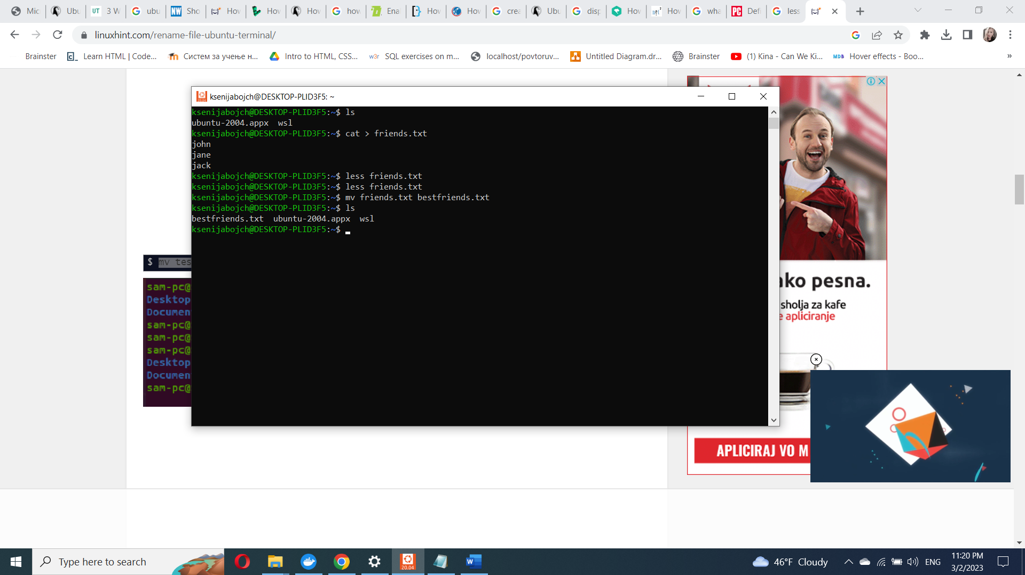

Rename file friends.txt to bestfriends.txt

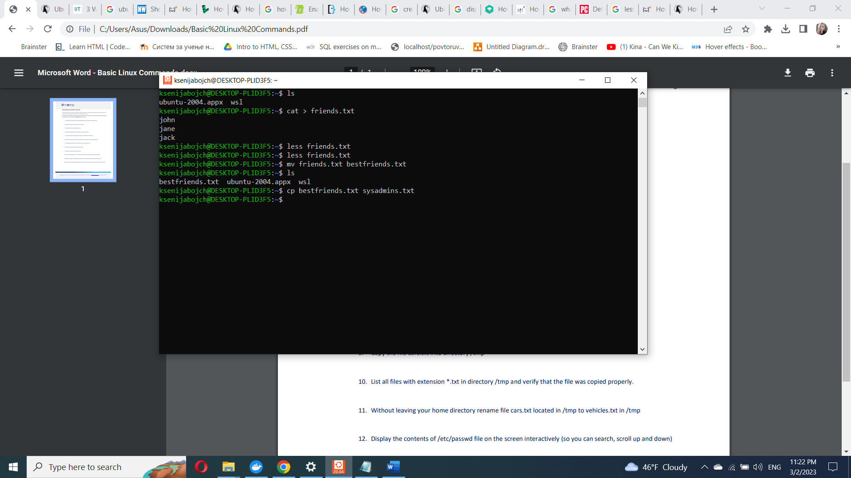

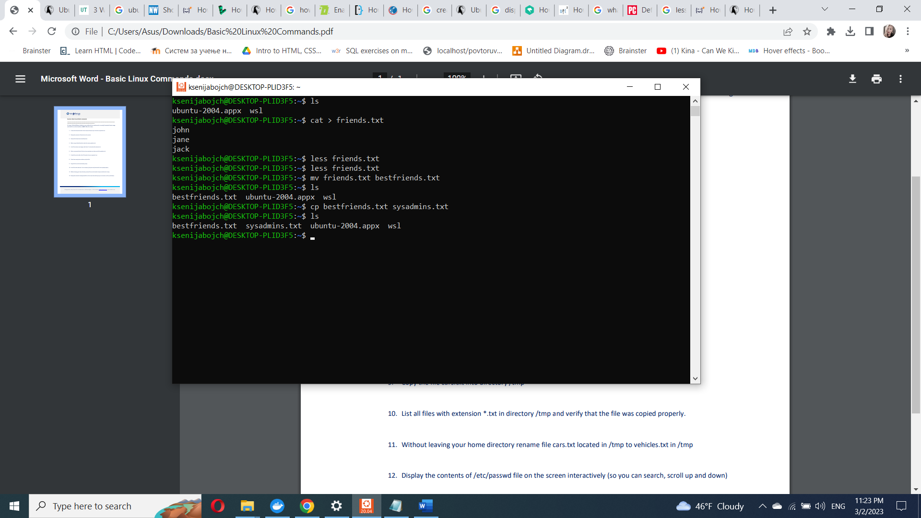

Make a copy of bestfriends.txt under the name sysadmins.txt

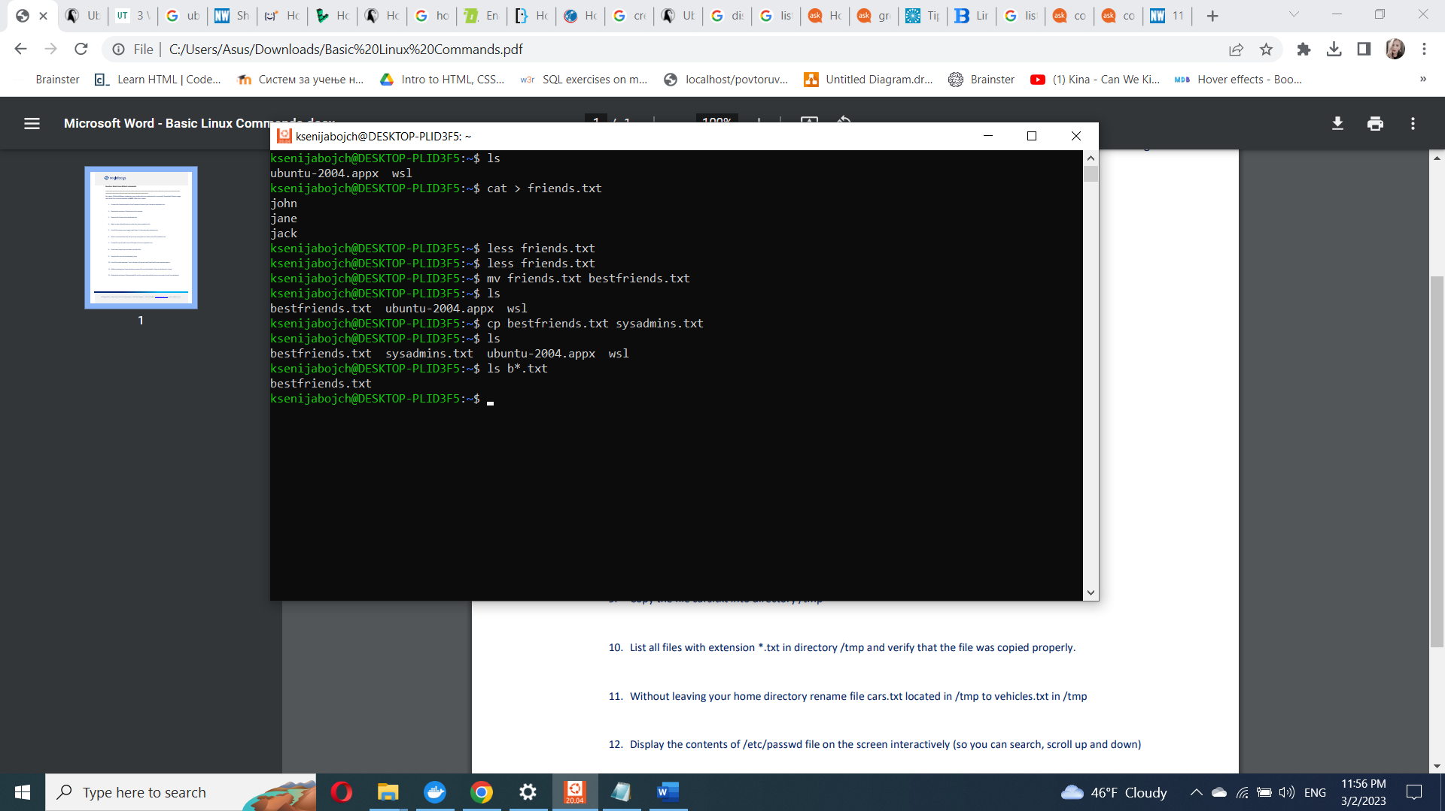

List all files whose name begins with letter 'b' and ends with extension txt.

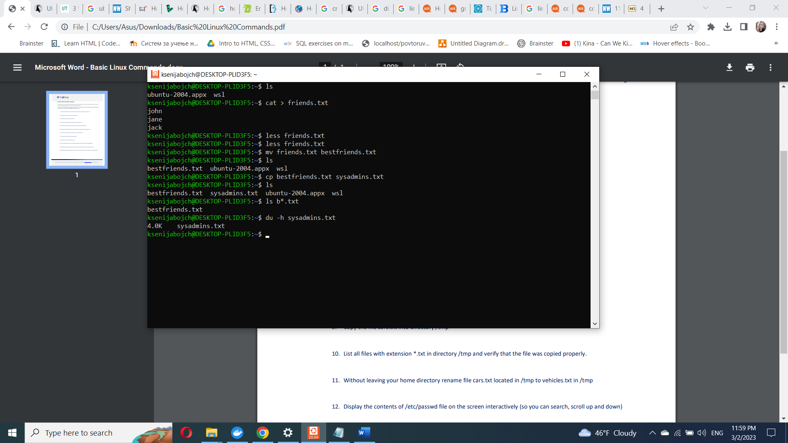

Write a command that will tell you how many bytes are taken up by file sysadmins.txt

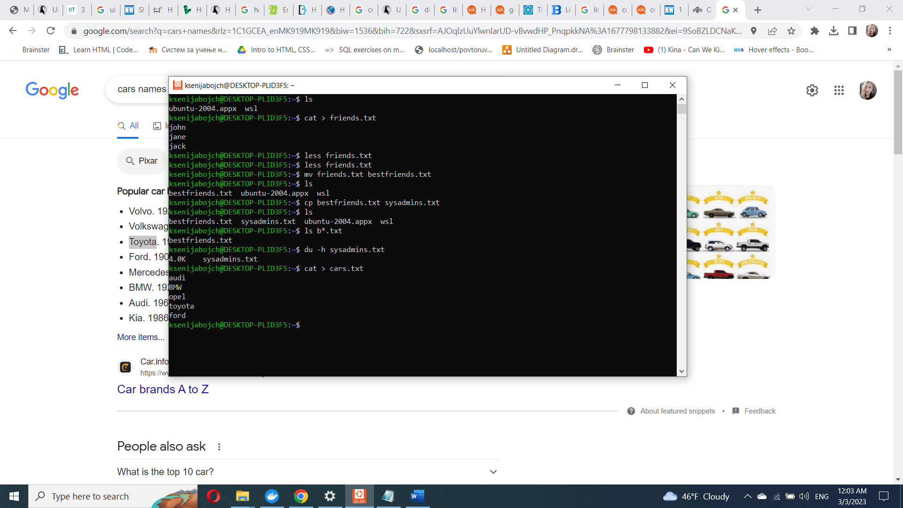

Create file cars.txt with a list of 5 brands of cars on separate lines.

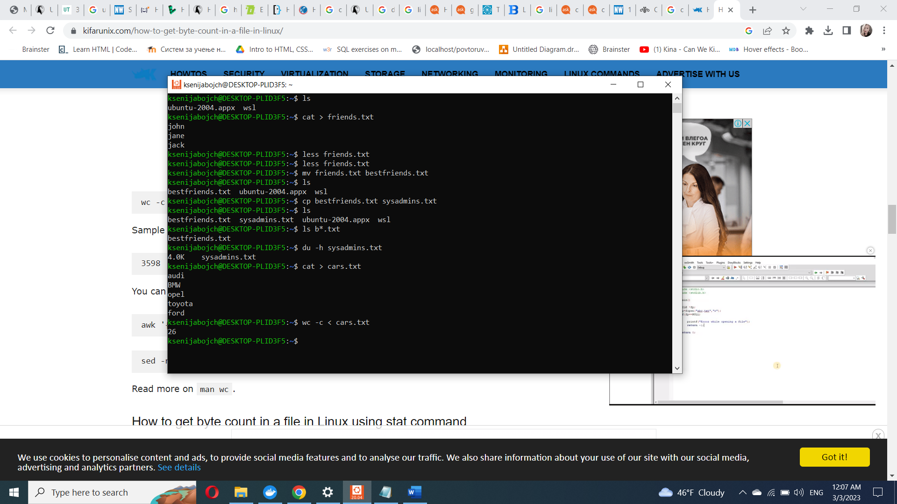

Check how many bytes are taken up by the file.

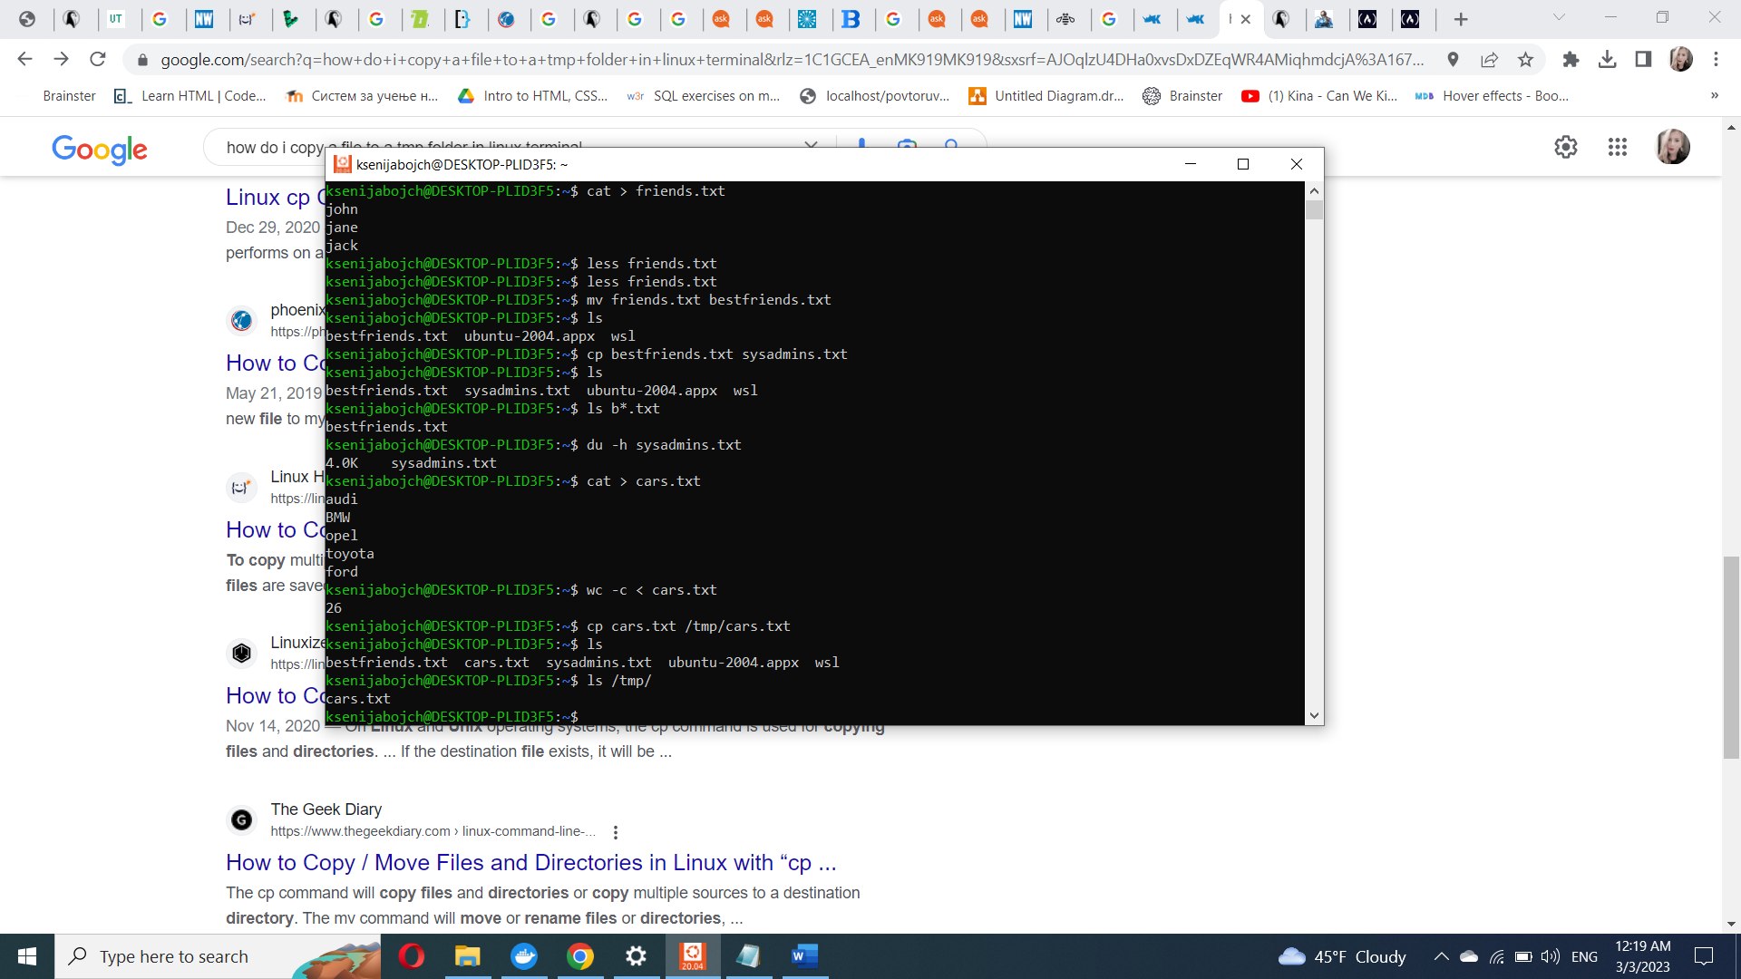

Copy the file cars.txt into directory /tmp

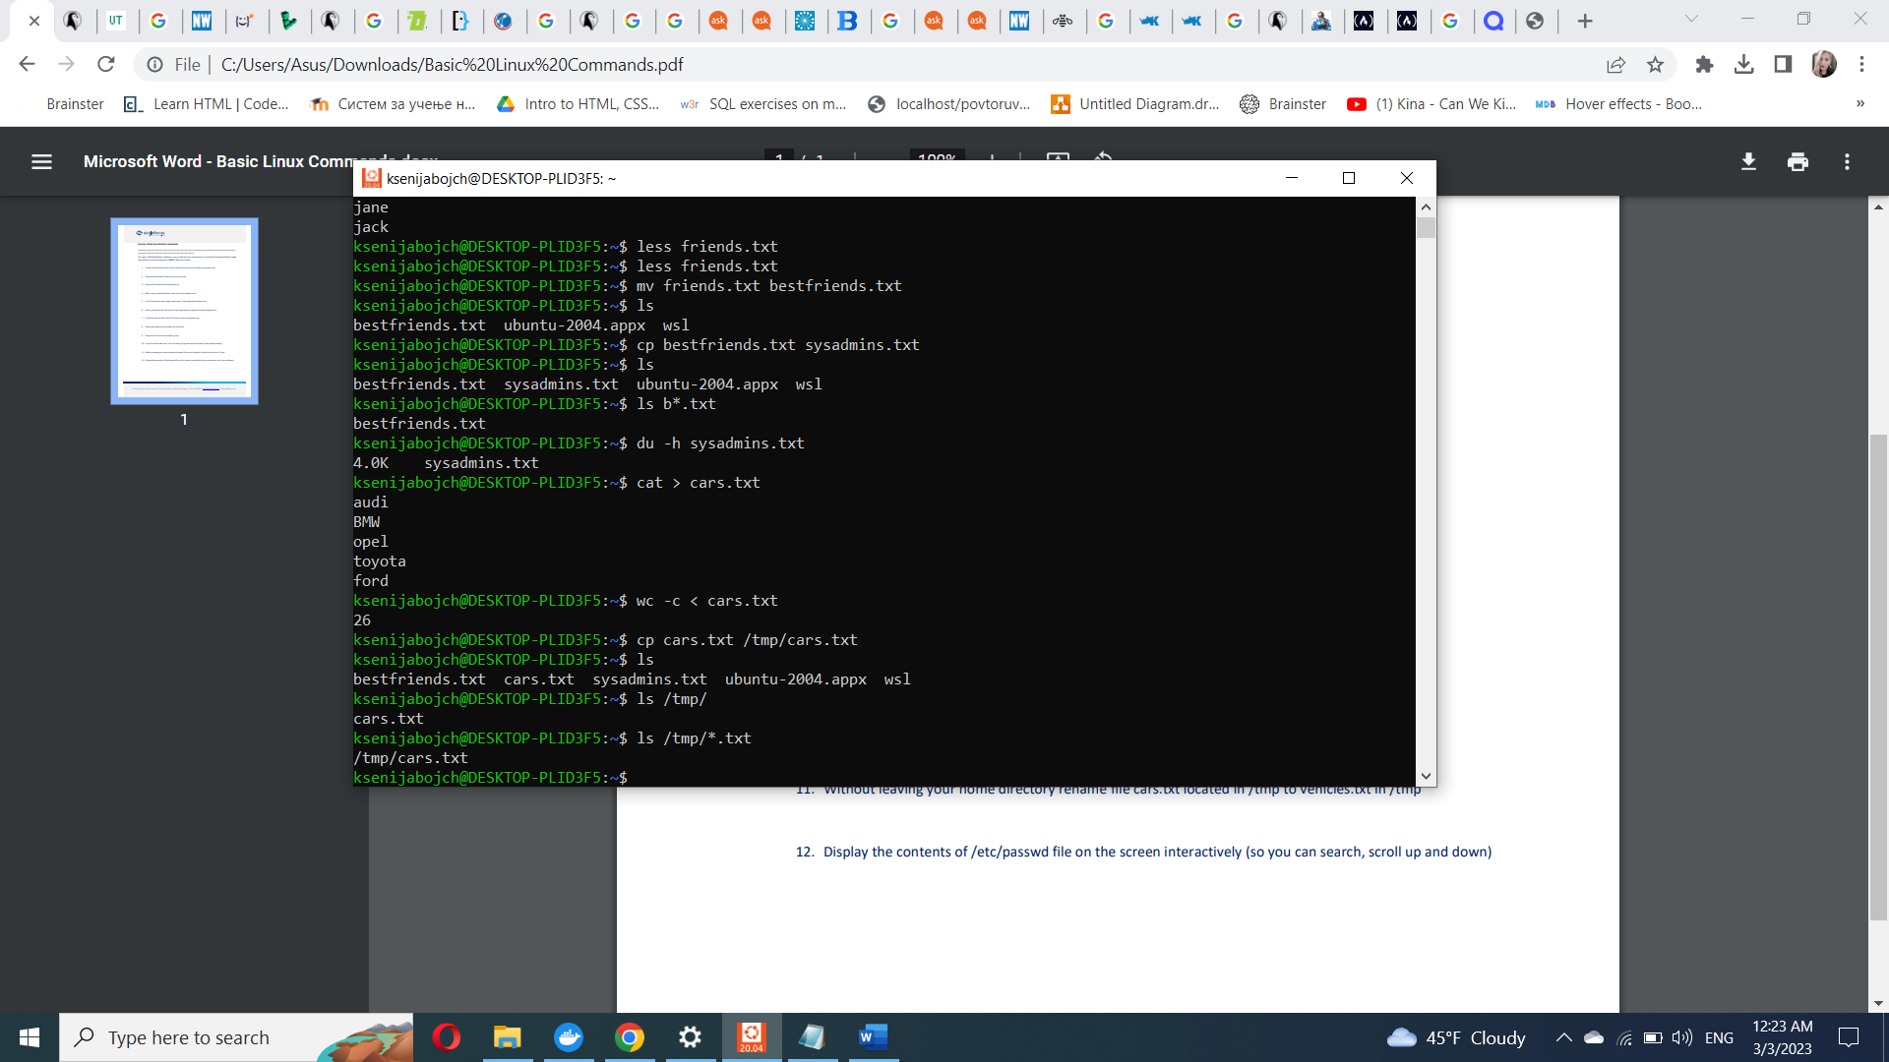

List all files with extension \*.txt in directory /tmp and verify that the file was copied properly.

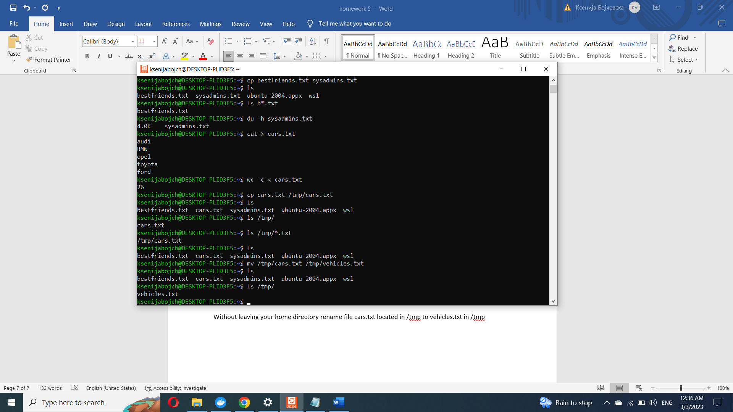

Without leaving your home directory rename file cars.txt located in /tmp to vehicles.txt in /tmp

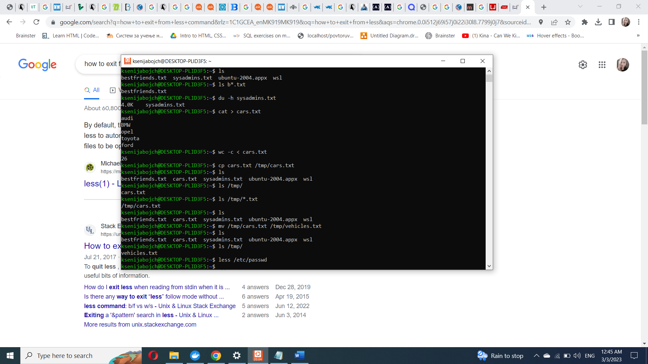

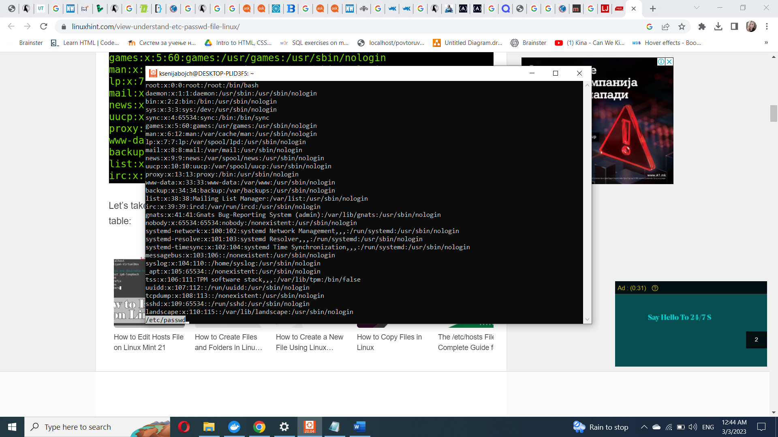

Display the contents of /etc/passwd file on the screen interactively (so you can search, scroll up and down)